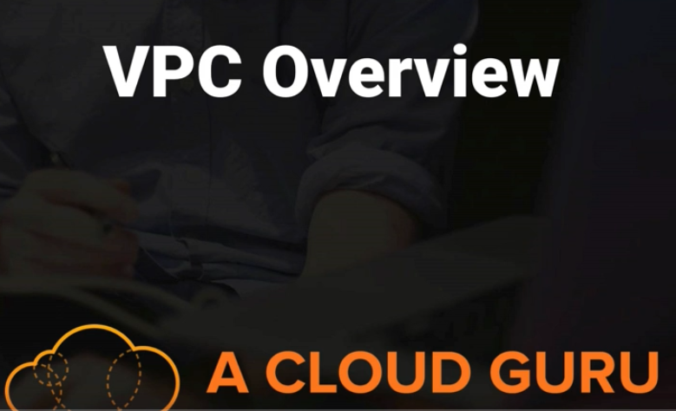

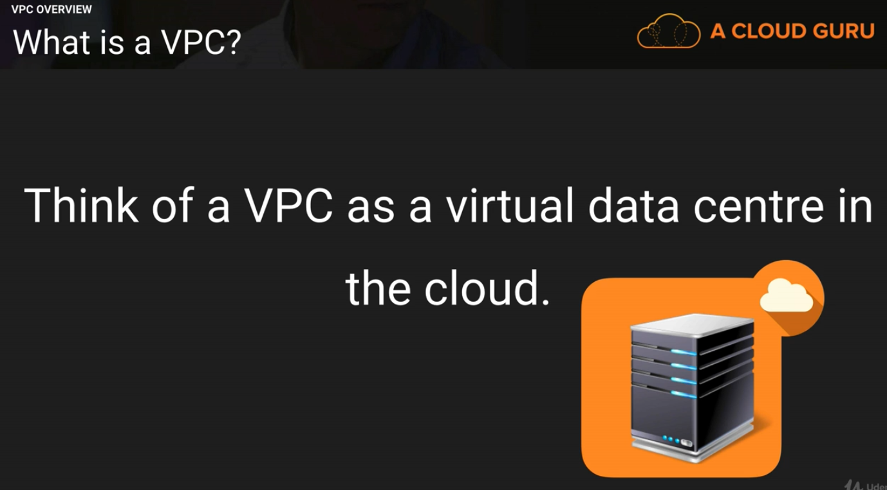

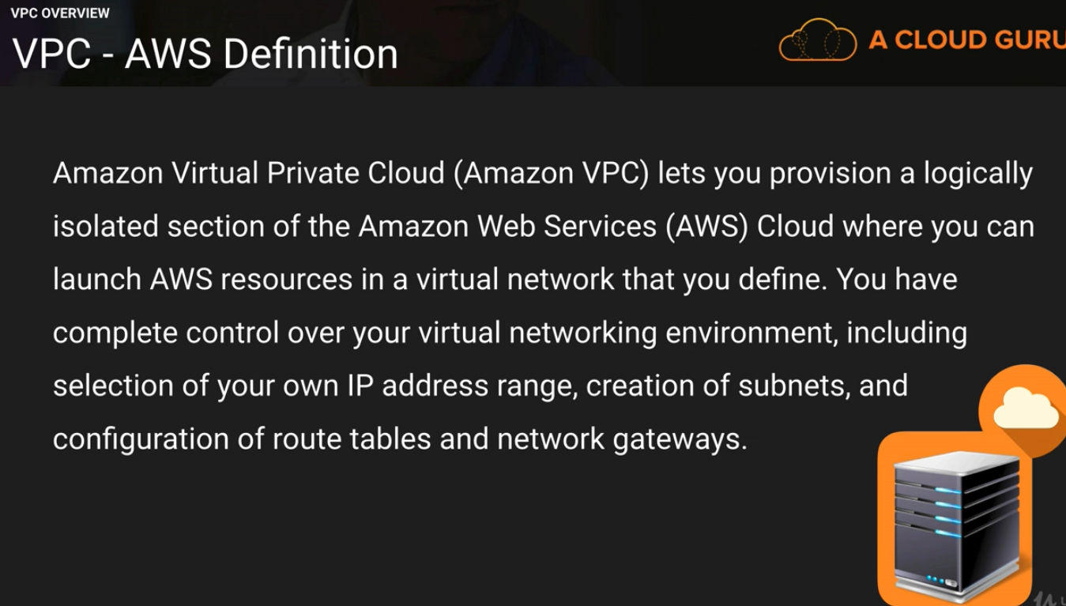

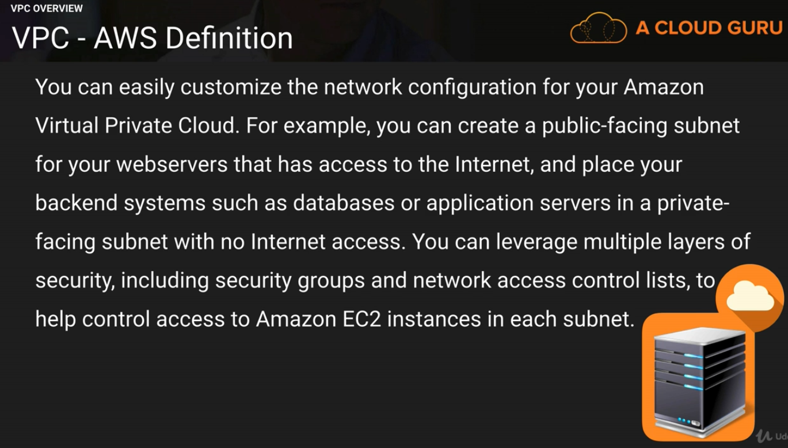

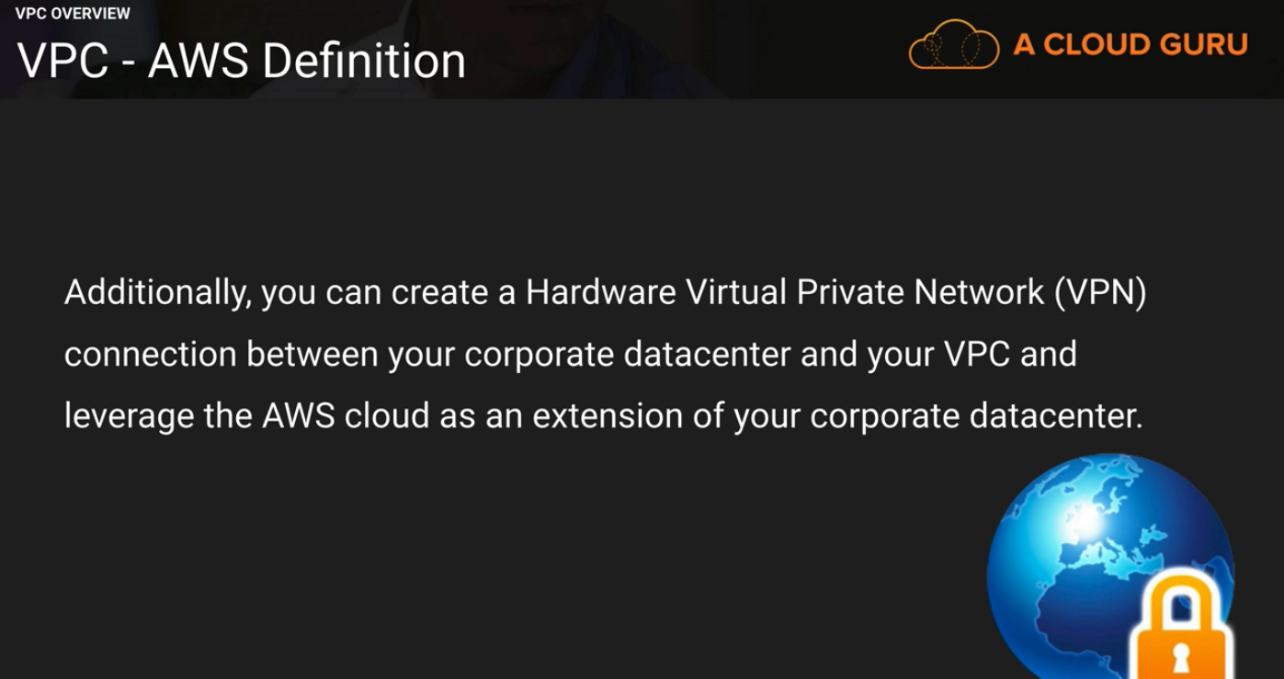

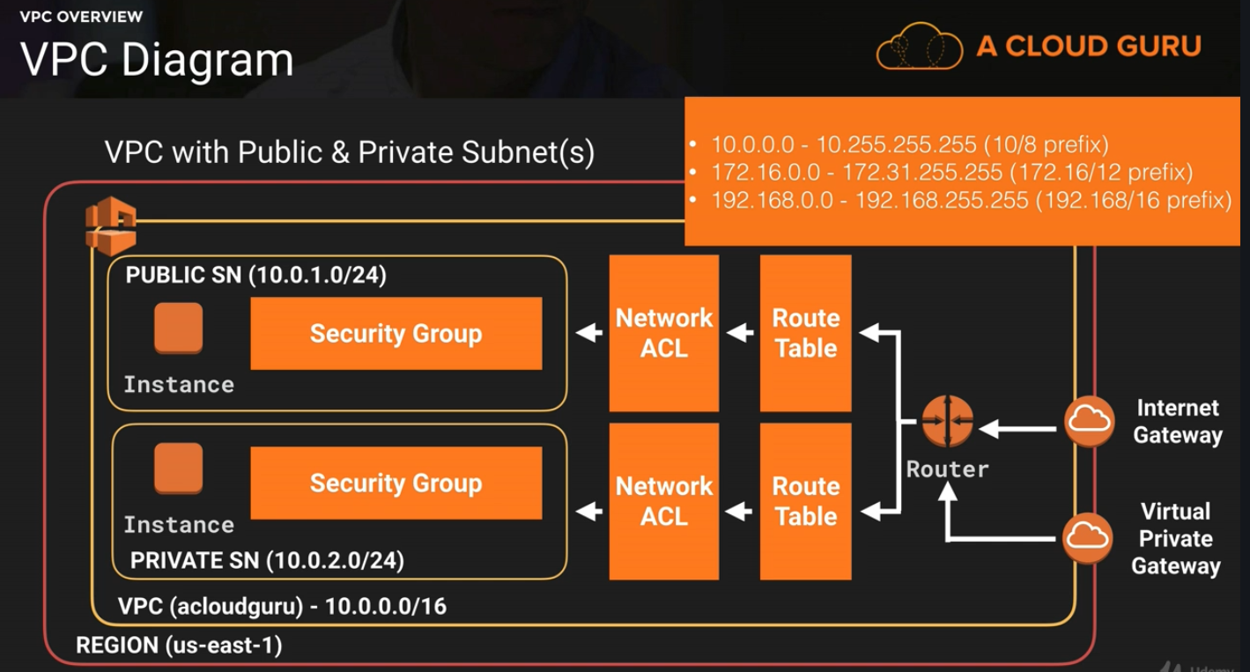

Visit CIDR.xyz to get different range of subnet ip address in a VPC.

**Note: One VPC can have only one Internet Gateway.**

**Internet Gateway by default highly available , so they are spread across all availability zone.**

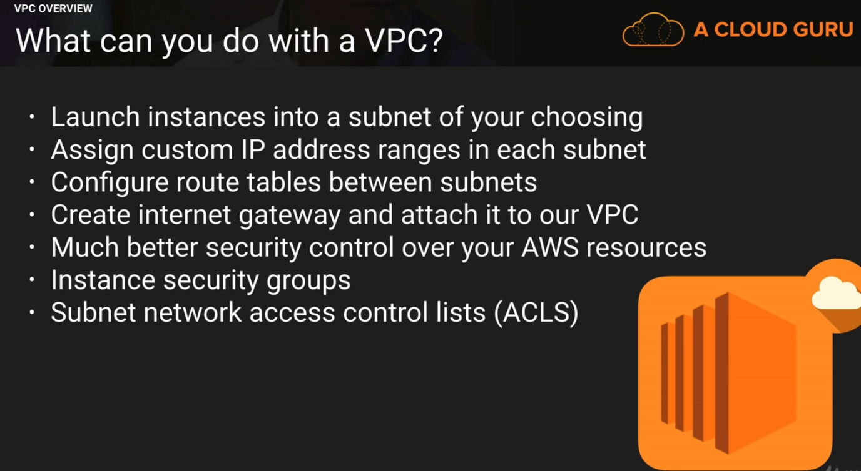

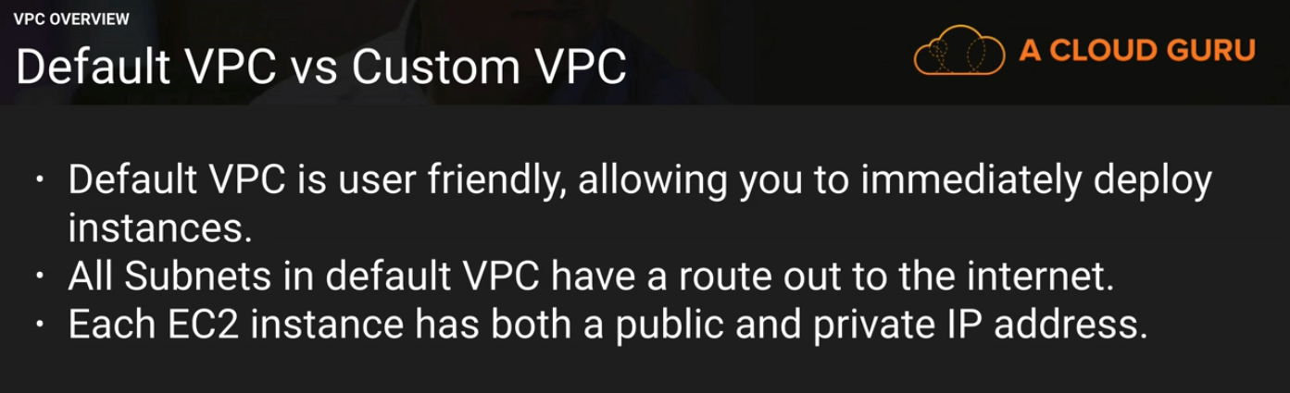

**We do not get private subnets in Default VPC**

**In custom VPC if we create private subnet the we are not going to get public IP. We will get only private IP.**

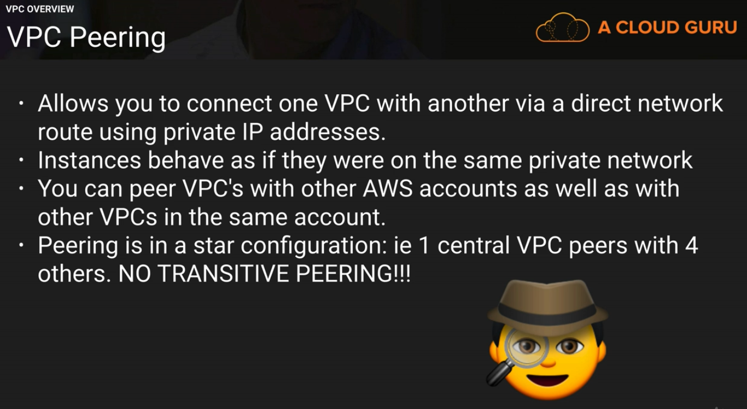

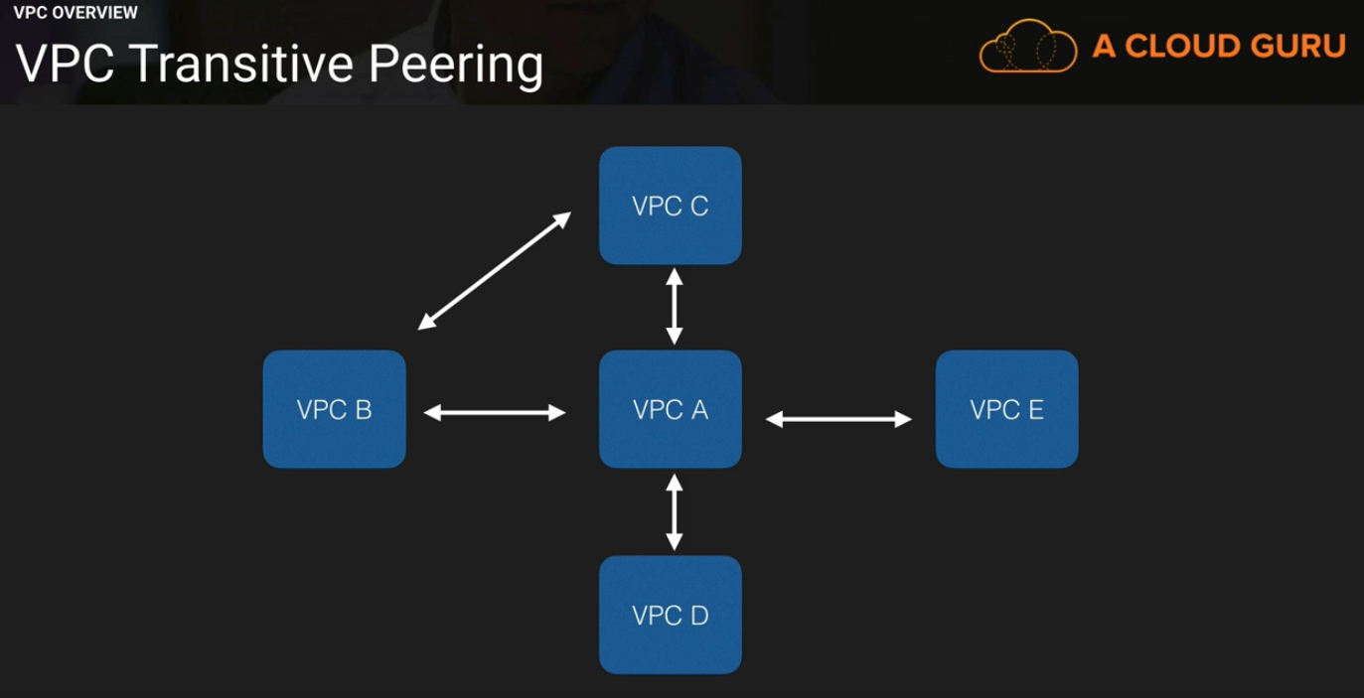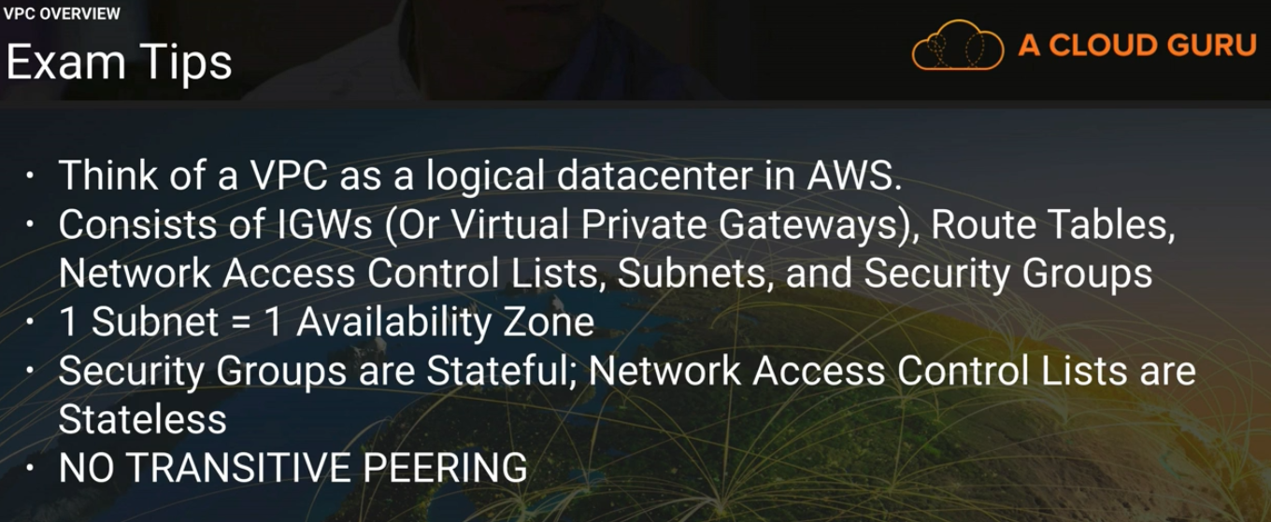



**We will be having on default VPC:**

Now we are going to create our own VPC:

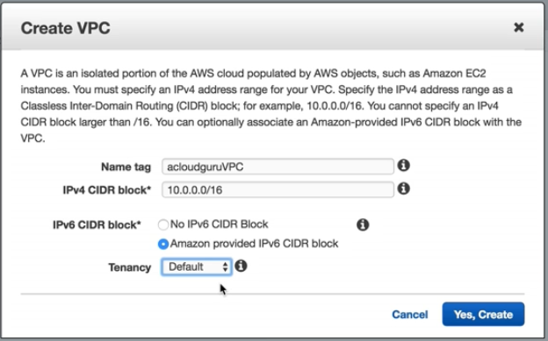

**As soon as we create our VPC a number of things will be created for us, this will include :**

**Route Table, Network ACL and Security group.**

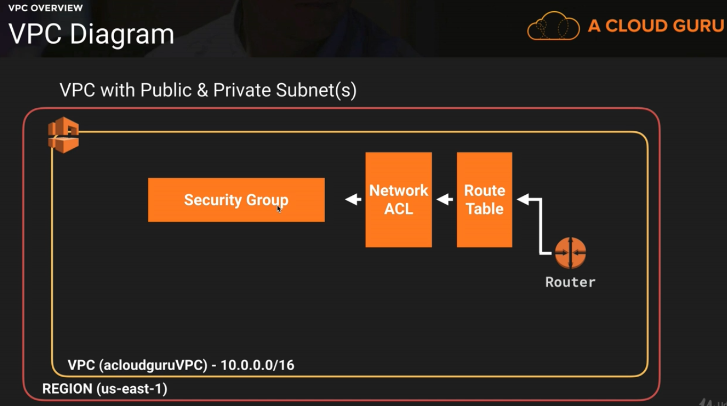

**Now create one subnet:**

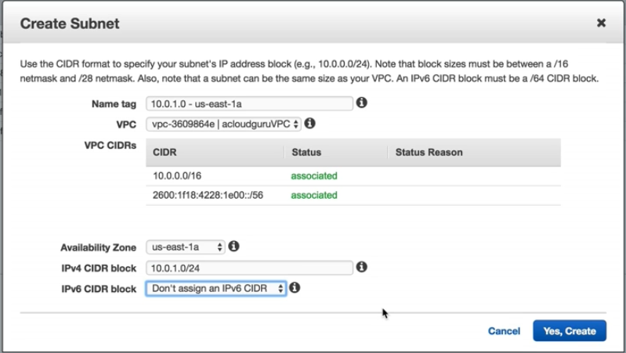

We can use only 251 ip addresses even if we have allocated 256 ip addresses.

Because 1st four and last ip addresses are reserved by aws for special use.

And auto assign public ip will not be enabled when we create a subnet. We have enable according to our requirement. If we are associating the subnet to a internet facing route table(that is if we are making any subnet public , then we will enable auto assign public ip)

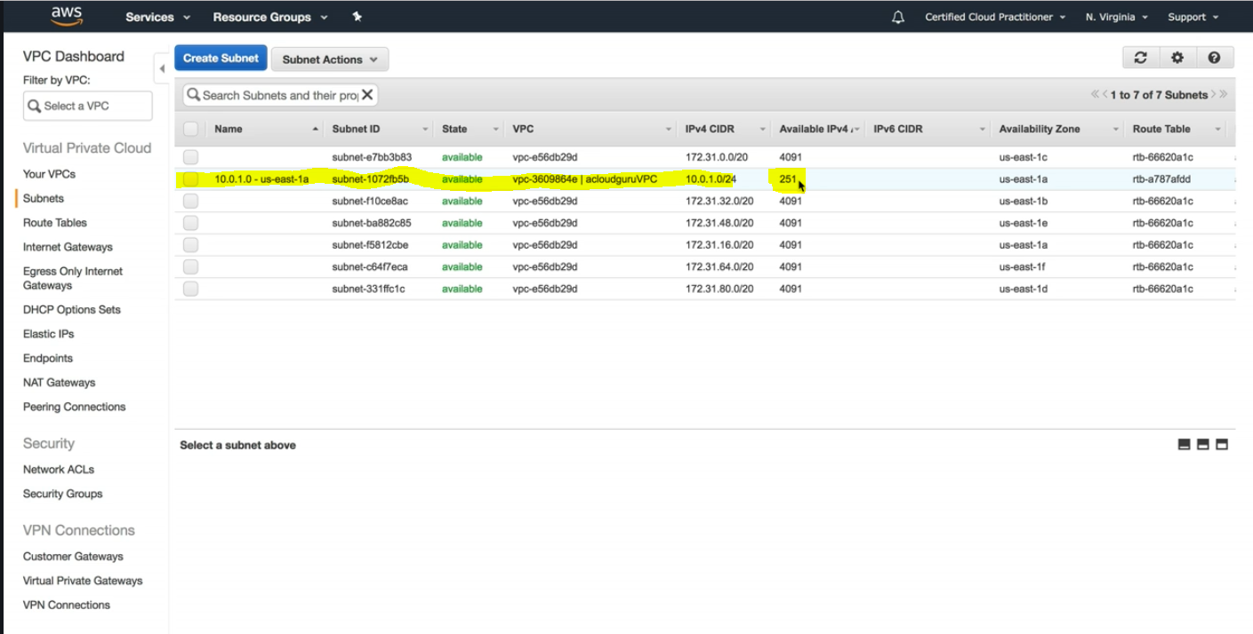

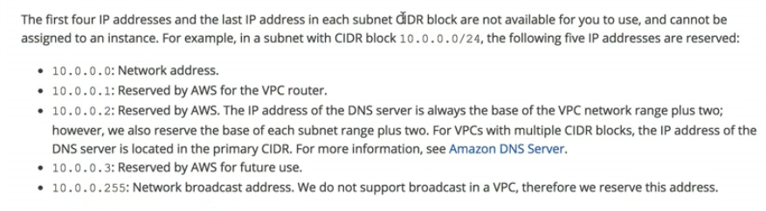

**Now , after creating two subnet:**

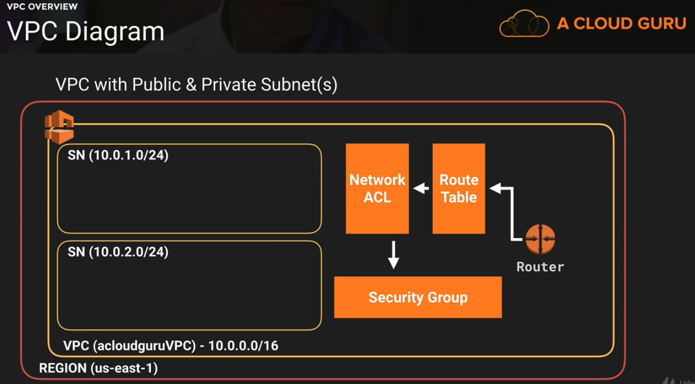

**Next one internet Gateway:**

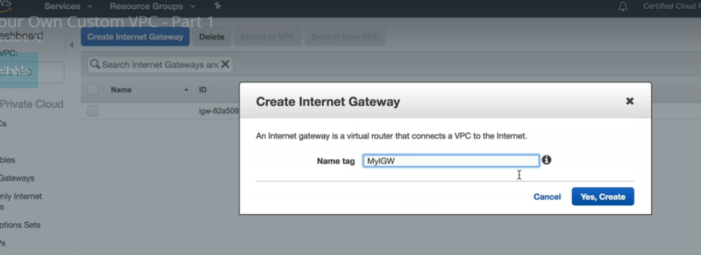

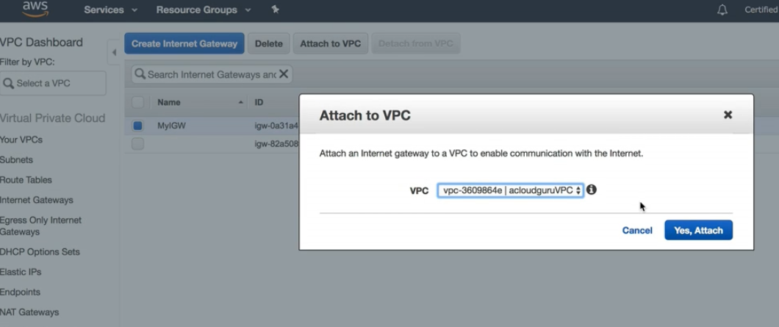

**Note: By Default Internet gateway will be in detach mode. We have to attach it to VPC.**

**Common Exam question: Only one internet gateway can be attached to a particular VPC.**

**We can not attach more than one internet gateway to a VPC.**

**Next is Route Table:**

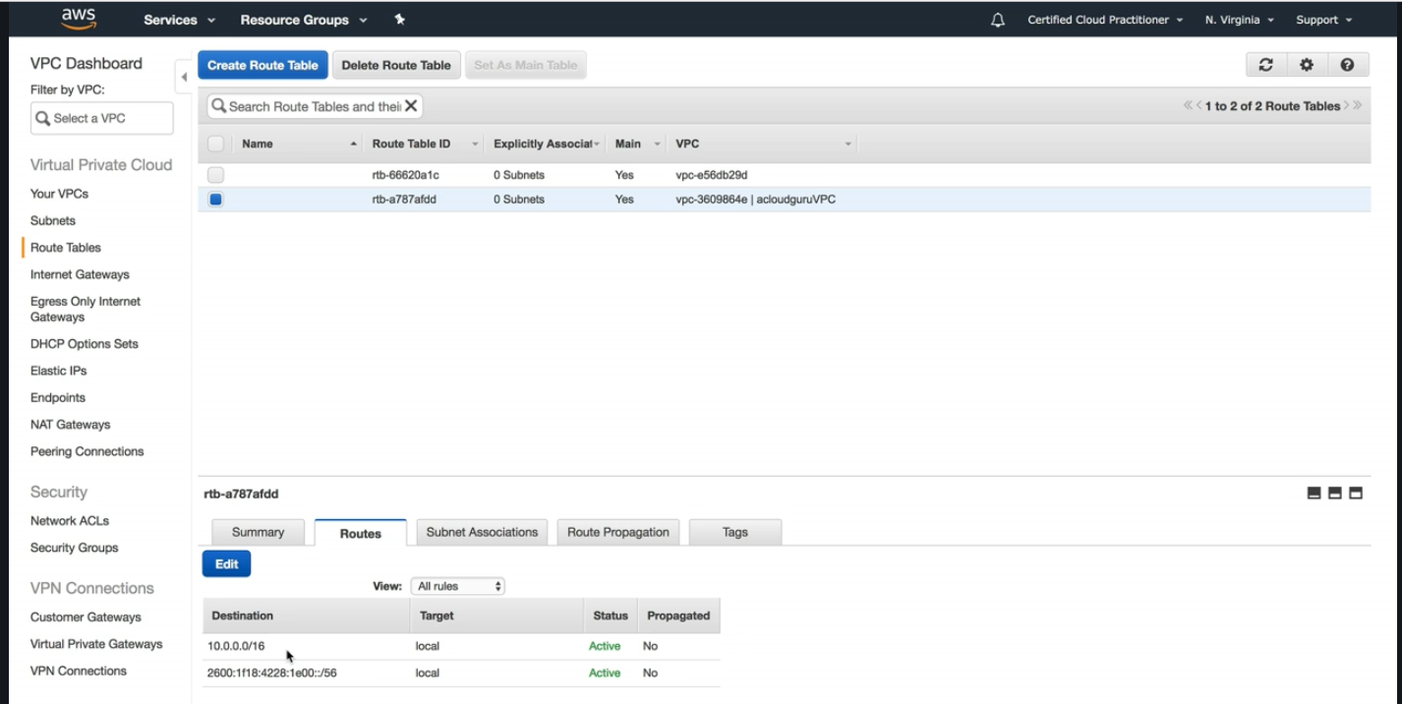

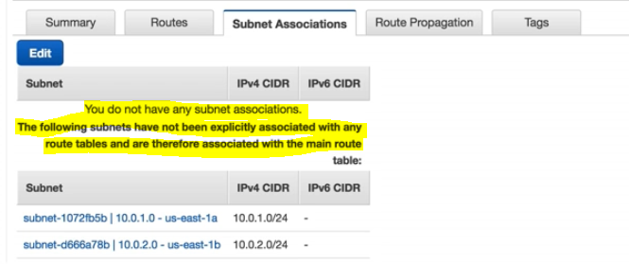

**Each time we create a subnet , it will associate to the main root table by default.**

**For that reason we don’t want to have internet access to our main root table.**

**So now we will create a new route table and enable internet access.**

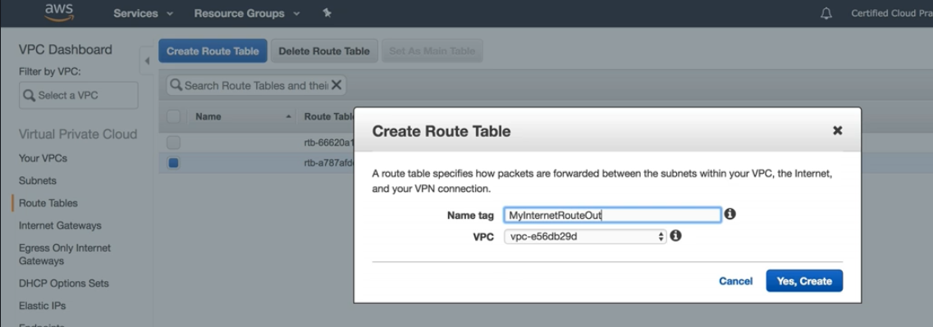

**After creating route table ,**

**Go to Routes🡪 then Edit🡪**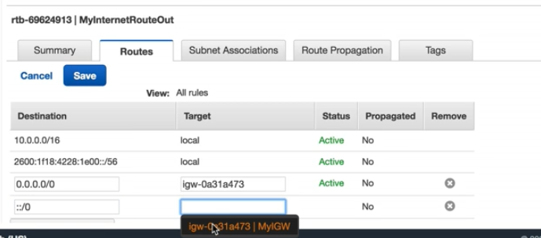

**Now go to Subnet association🡪then Edit🡪**

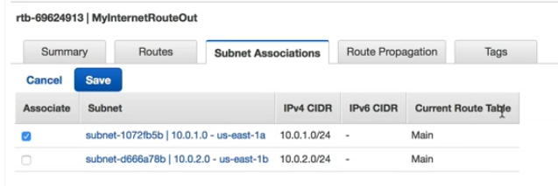

**Now enable auto assign public ip for the public subnet.**

[auto assign public ip will not be enabled by default when we create a subnet. We have to enable according to our requirement. If we are associating the subnet to a internet facing route table (that is if we are making any subnet public, then we will enable auto assign public ip to get IPv4 address of the EC2 instance. Otherwise EC2 instance in that subnet will no be accessible from internet)]

Go to Subnet🡪Subnet action🡪 Modify auto-assign IP settings.

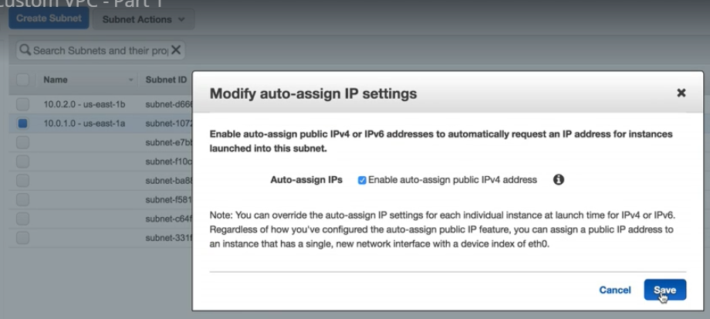

**Next create a EC2 instance under the custom VPC that we have create and assign the subnet(which is public) and configure Security group (Web-DMZ) with ssh and http rule , as it is internet accessible.**

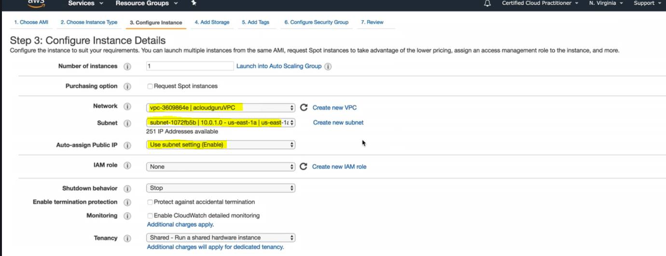

**And Next create a EC2 instance under the custom VPC that we have create and assign the subnet(which is private) , for this instance assign default security group.**

**Till now we have completed till:**

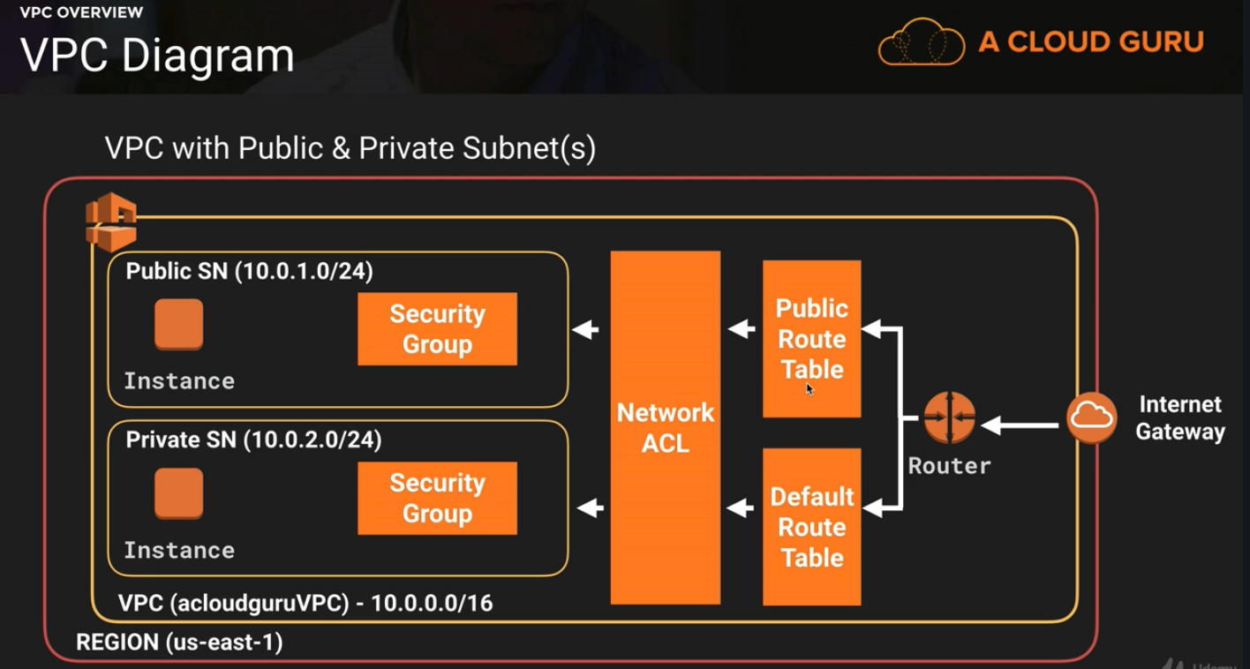



**Now create a new security group as below**

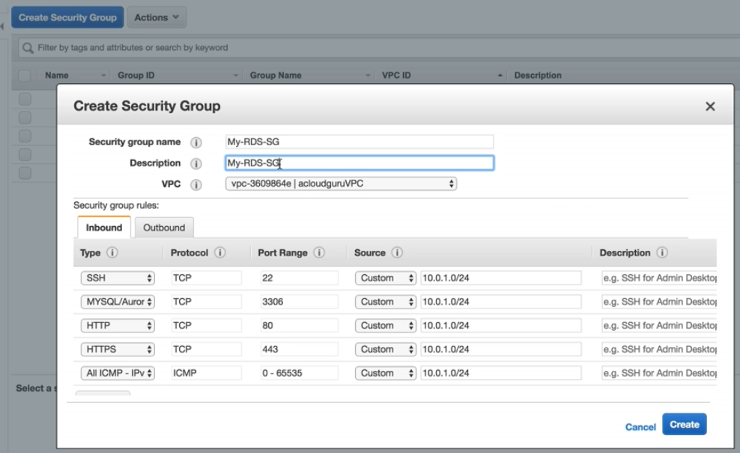

**And assign the created security group to the private ec2 instance.**

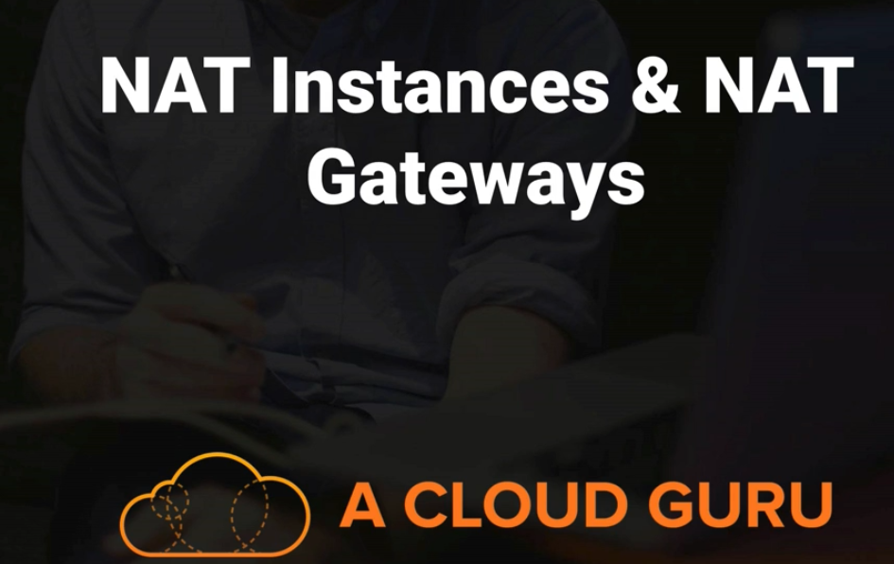

**To enable internet access to our private EC2 instance in private subnet.**

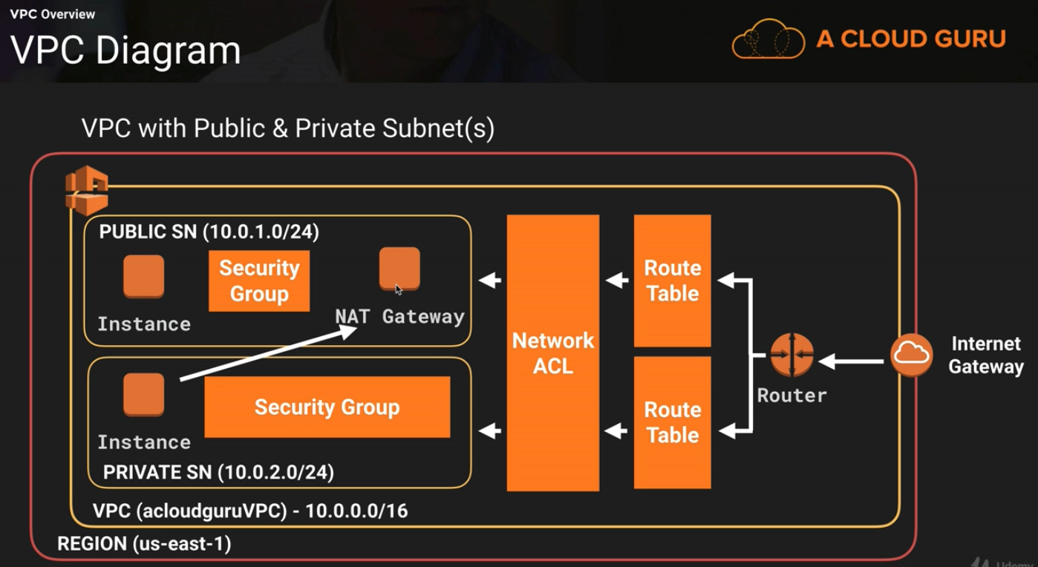

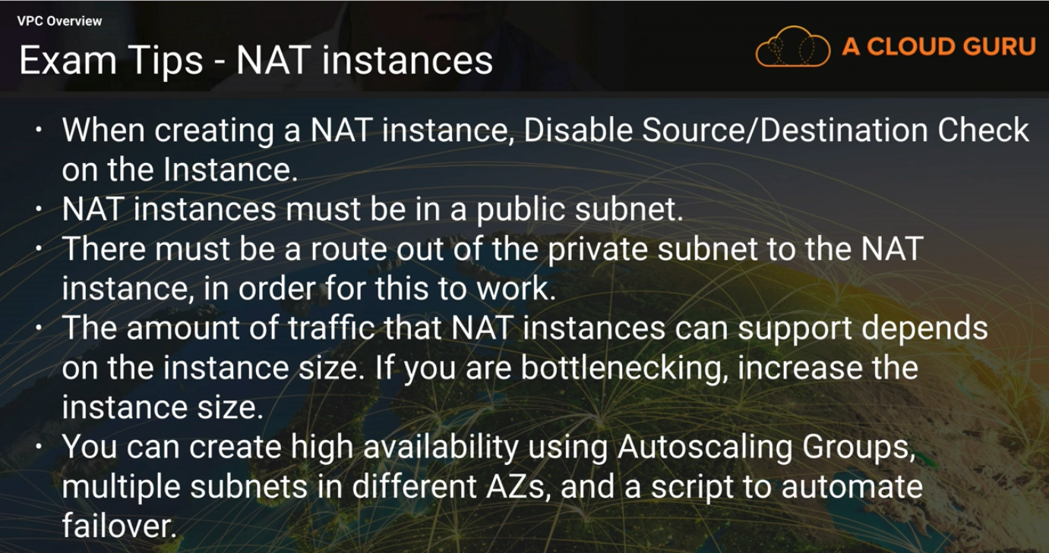

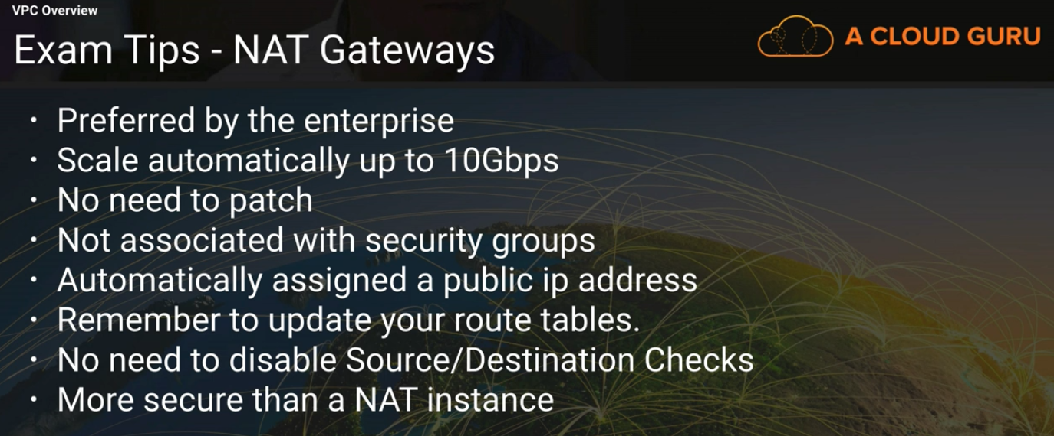

**Network Access Control Access List:**

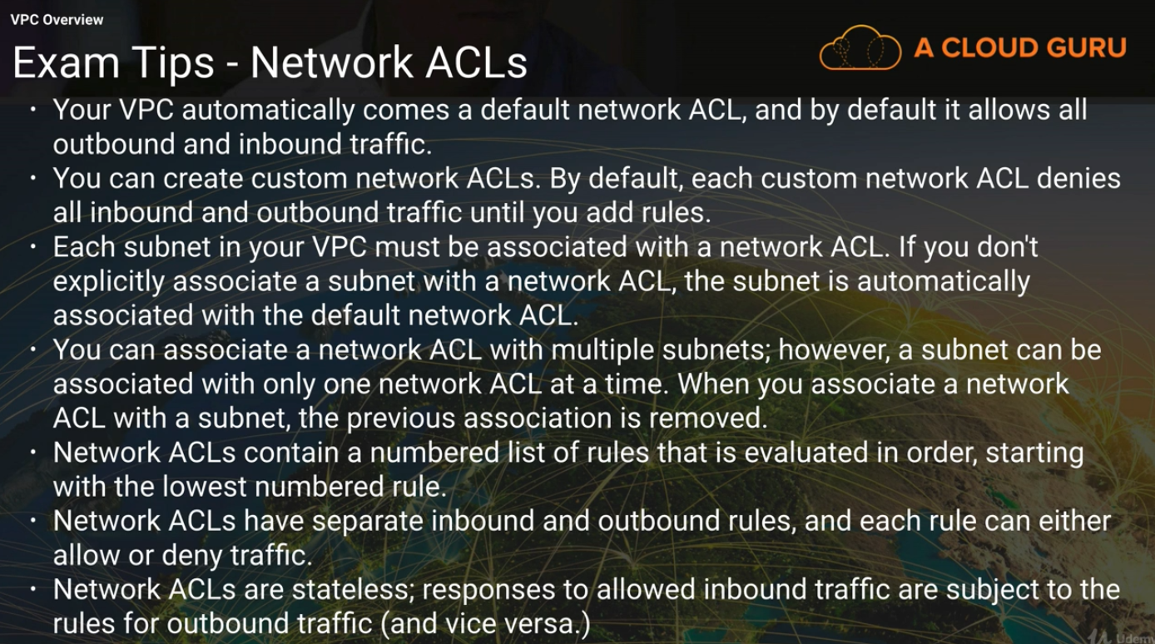

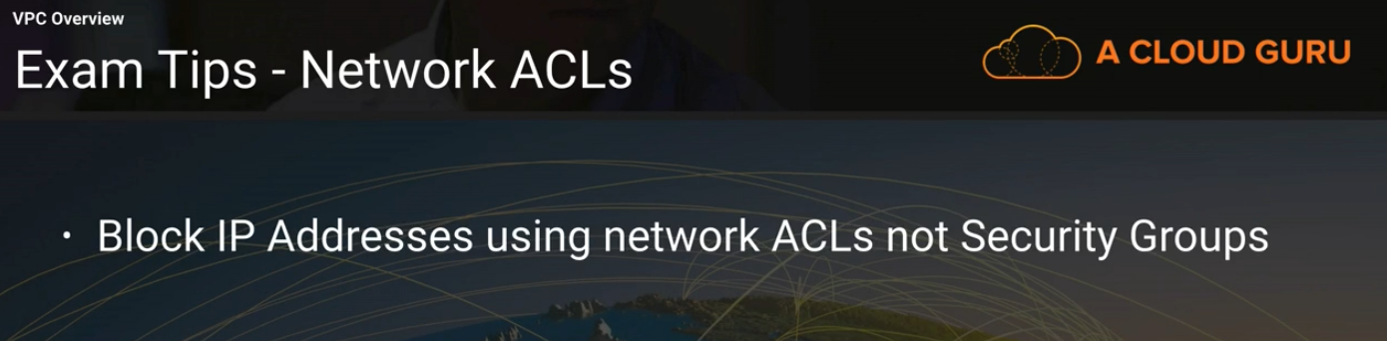

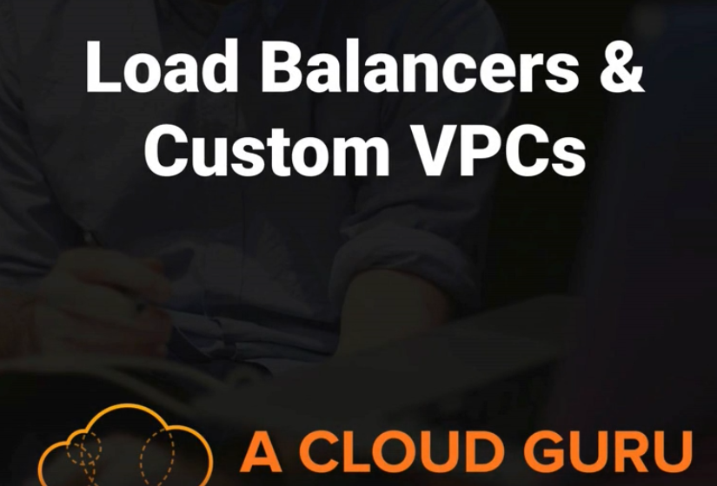

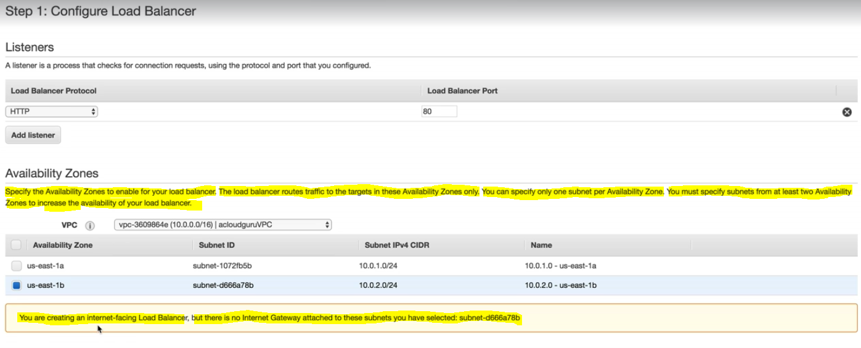

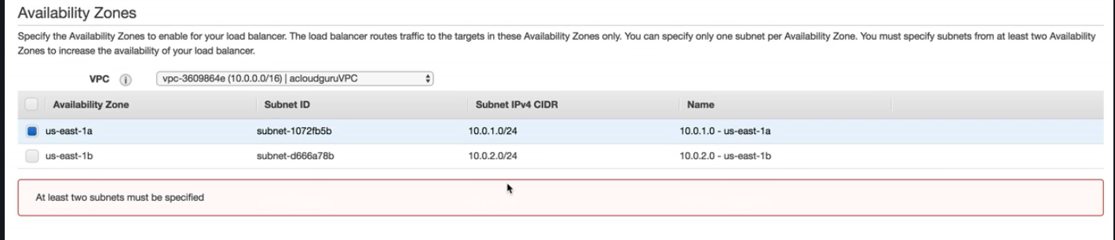



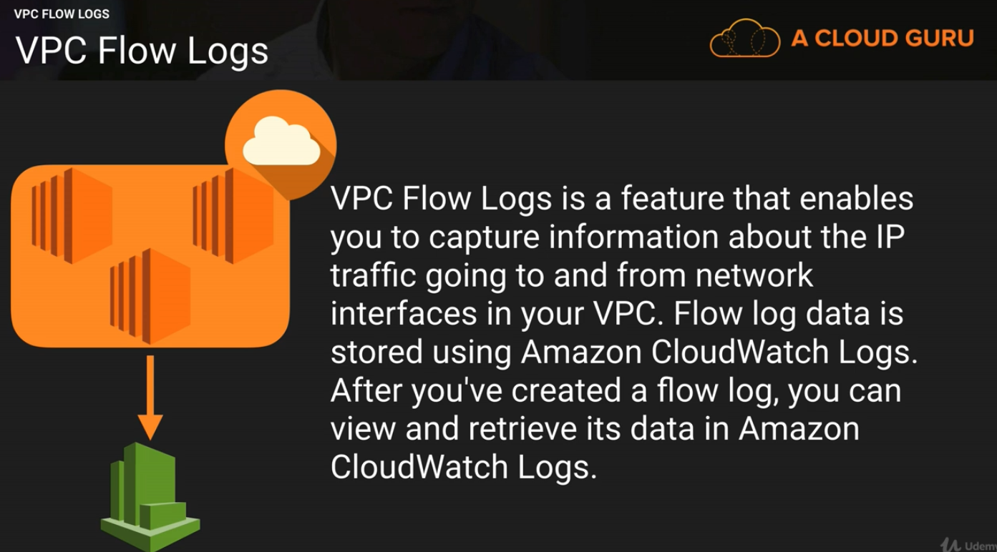

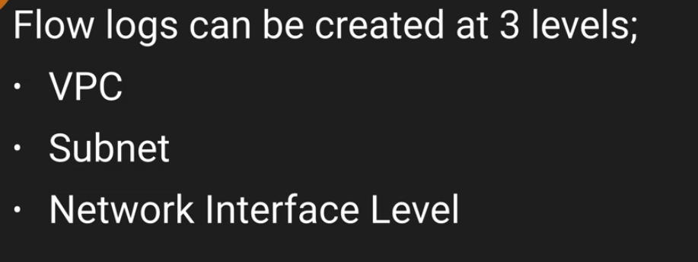

**To enable Flow log in VPC :**

1. **Create a role inside IAM**
2. **Create a log group inside cloudwatch**
3. **Select the VPC then got to 🡪 Action🡪**

**Create flow log**

1. **Insert below details:**

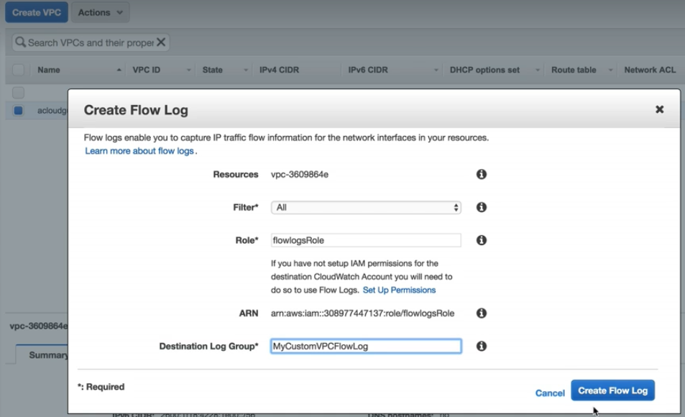

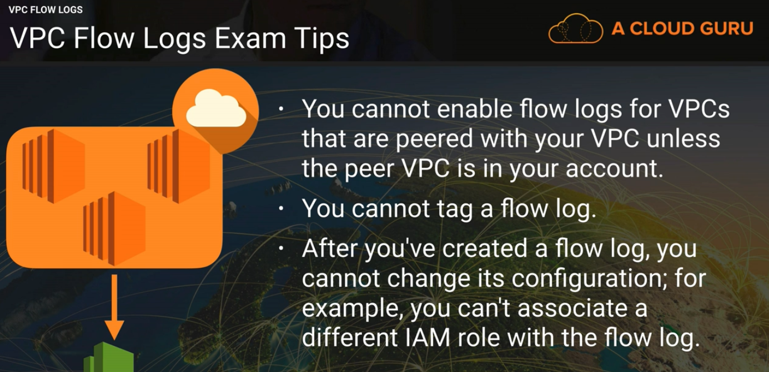

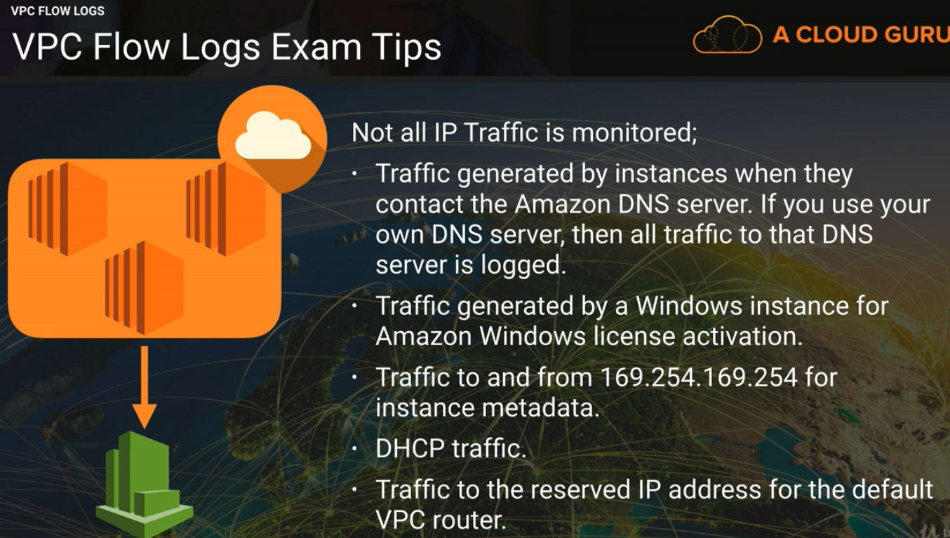



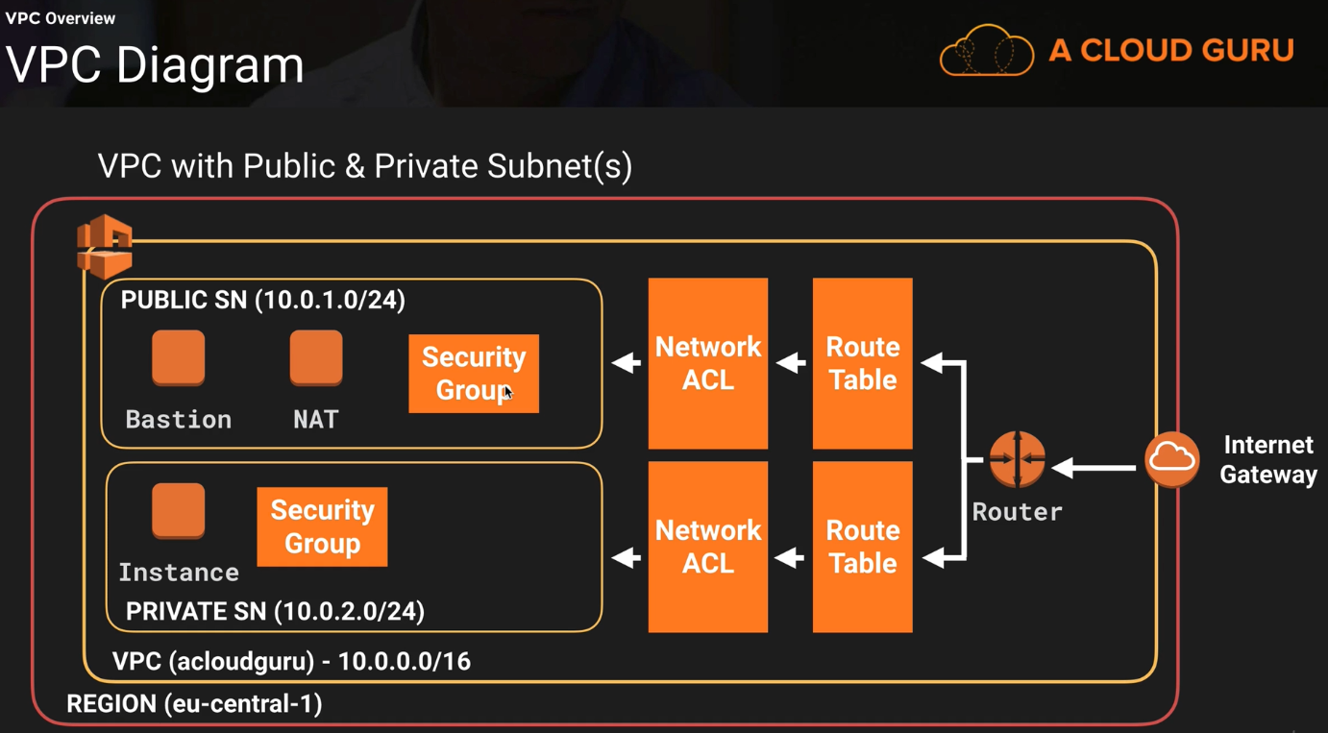

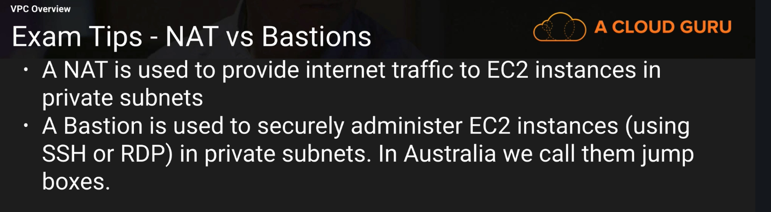



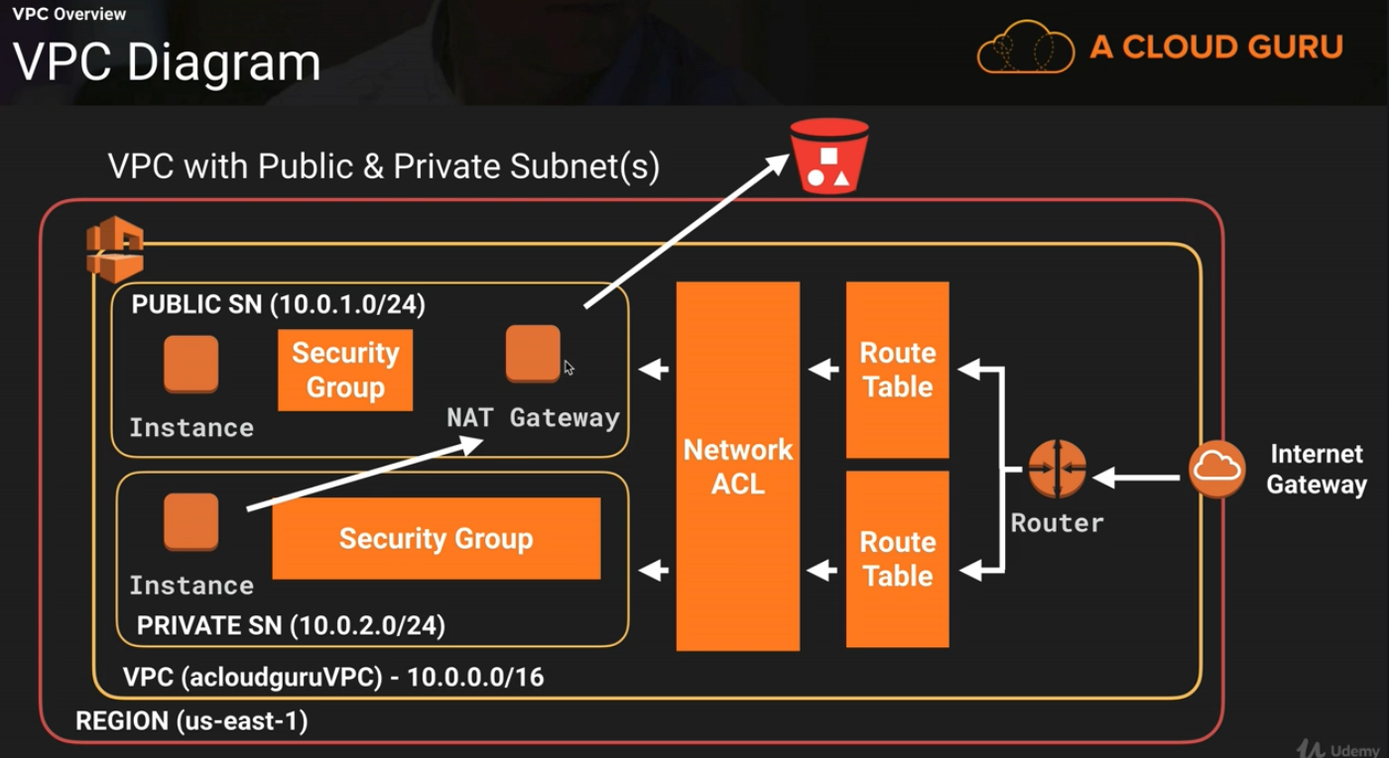

**Summary**

